A Review of Critical Steps for Implementing
Public-Private Partnerships in Brazil

Cesar Queiroz
Consultant
4601 N. Park Ave
Chevy Chase, MD, 20815
USA
Tel 301-755 7591
queiroz.cesar@gmail.com

Carlos Eduardo Motta
Consultant
Rua Osvaldo Cruz, 1 Sala 612
Meireles, Fortaleza, CE, 60125-150
Brazil
Tel 55-85-30478797
cemo@globo.com
http://cemottaadvocacia.jur.adv.br/

January - 2012
Washington, DC, USA

Abstract

A review of how a PPP project can be prepared and implemented in Brazil is presented, pointing out the main responsibilities of the public and private actors in the process. The description and discussion of critical concepts and steps in the process serve as a general guidance for domestic and international investors interested in participating in competitive selection of concessionaires in Brazil.

In order to make PPP projects more attractive to private investors, the Brazilian PPP law provides the public contracting entity with several options to extend guarantees to the private partner, including those given by the PPP Guarantee Fund, guarantees linked to revenues, and guarantees provided by international financial institutions.

The Brazilian PPP framework provides for a balanced partnership that is advantageous to both contracting parties. While the government has an opportunity to accelerate the completion of new investments required to promote the country’s economic and social development, the private partners, domestic or international, have an opportunity to generate long lasting cash flows with relatively low risks in view of the financial support and guarantees from the public partner.

Recommendations for further improvement of the Brazilian PPP law are made regarding two dimensions, namely public disclosure and mechanisms for renegotiation.

INTRODUCTION

Several developing and transition economies currently face a serious scarcity of public resources for investments in economic and social infrastructure, thus limiting their ability to meet the demands called for by society.

Brazil, in particular, faces increased demand for investments in transport infrastructure, energy, education, health, sanitation and security, activities that are essential to sustainable development. This is, in part, due to the recent economic crisis, fiscal austerity, and the high cost of the public debt.

In this scenario, the state turned to the productive sector, creating mechanisms to attract private sponsors to invest in sectors traditionally of the responsibility of the state. Such mechanisms made possible broader application of the instrument of the Public-Private Partnership (PPP) in the country.

The PPP legal framework was established through the Brazilian federal Law 11,079, of December 30, 2004, which brought out the general rules for tendering and contracting this type of partnership. The law also set up the guidelines to be followed, reflecting the caution the legislators want the public administration to observe when opting for such form of contracts.

This study aims to review how a PPP project can be developed in Brazil, including the main steps (e.g., technical, legal, social) in a way to serve as a guide to potential partners and other actors interested in the process. Particular emphasis is given to the competitive selection of concessionaires, as a “poor” private partner could contribute to the worsening of fiscal problems and reduced efficiency in the delivery of public services to society. Also reviewed are the institutional arrangements for PPP projects in the transport sector.

THE PPP LEGAL FRAMEWORK

The positive international experience served as an incentive to enacting the legal framework in Brazil in 2004, at the height of the reform process of the state, then marked by the privatization of large public enterprises, deregulation of the economy and, also, the Brazilian experience in the use of more traditional forms of concessions, which were adopted in sectors such as roads and railways since the 1990s.

The Brazilian PPP Law 11.079/04 establishes general rules for competitive bidding and contracting the private partner at both the national and sub-national levels. The PPP law complements the concession laws (Laws 8.987/95 and 9.074/95) and the procurement law (Law 8.666/93). The law also established an organizational structure in the federal government to oversee the Brazilian PPP program.

Among its features, the PPP law allows government entities to assume long-term commitments, including the payment of subsidies to service providers, with the overall objective of increasing efficiency. Accordingly, the PPP legal framework contains provisions that prevent the administrator to adopt projects without proper prioritization studies and to assume future financial commitments for which there would be no assured source of financing. The law also requires public hearings to be held, and economic and financial assessments to be carried out for each proposed PPP project.

Rocha and Horta (2010, p.30) define the Brazilian PPP model as special concession arrangements through which the Administration delegates to a private partner the provision of a service, with or without prior construction works, and remuneration paid by the users and the state, or only by the state.

Based on the federal law, Brazilian states and municipalities can enact their own PPP laws. As an example, the states of Minas Gerais and São Paulo implement their PPP projects according to PPP state laws, which have been enacted in harmony with the federal PPP law. Henceforth, the federal PPP law will be referred to as PPP law.

BASIC PPP PRINCIPLES

According to article 4 of the PPP law, the following principles must be observed at all stages of the process to select the private partner:

- Efficiency in delivering services and using public funds;
- Respecting the interests and rights of recipients of services and private entities responsible for service delivery;
- Retaining in the public sector the regulatory functions, the exercise of police power, and other strictly state tasks;
- Fiscal responsibility in the contracting and implementation of partnerships;
- Transparency of procedures and decisions;
- Objective sharing of risks between the parties; and
- Financial sustainability and socioeconomic benefits of partnership projects.
The PPP project preparation steps discussed in the paper follow the above principles, so as to guide interested parties in the implementation of PPP projects under the Brazilian legal framework.

SPONSORED AND ADMINISTRATIVE CONCESSIONS

The Brazilian PPP legal framework defines PPP as a concession contract that may take one of two forms: (a) “sponsored” concession; or (b) “administrative” concession.

In a sponsored concession, the private partner revenues come from (a) fees charged to the users, and (b) financial subsidies paid by the contracting public entity as the services are delivered.

In the case of administrative concessions, the contracting state entity pays fully for the services provided; there are no user fees.

If a project is shown to be financially viable without any public funding, instead of falling under the PPP law, it should be managed as a “common” concession, to be bid and implemented under the country’s concession laws and other related norms.

BASIC PPP CONCEPTS

The Brazilian PPP law provides several useful definitions, such as:

- The Public Partner - may include government agencies, special funds, municipalities, public foundations, public companies, joint stock companies and other entities controlled directly or indirectly by the Union.
- The Private Partner – should be a Special Purpose Company (or SPE, using the Brazilian acronym), to be established by the successful bidder. The SPE is usually a consortium of entrepreneurs and investors who will fund and manage the PPP project.
- Types of PPP – may include typical public services, such as roads and other transport infrastructure, transportation services, sanitation, health, and education. Services to be provided to the public administration can also be contracted as a PPP.

The PPP law, however, states that PPPs cannot be used with the single objective of supplying labor, the supply and installation of equipment, or to carry out public works. It also specifies that no PPP contract can be worth less than R$20 million (about US$12.5 million) or last less than five years.

The financing of PPP projects by state enterprises is limited to 70 percent of the total resources required, a limit that can increase to 80 percent if the project is located in areas with low human development index (HDI) in the North, Northeast or Midwest regions of the country. A specific legislative authorization is required for a sponsored concession to receive public support above 70 percent of its total cost.

The ability to generate revenues is a key factor in the choice of the form of concession. Common concessions apply to self-sustaining projects, while PPP projects (i.e., sponsored or administrative concessions) are those that require public financial support.

PPP INSTITUTIONAL ARRANGEMENTS

In Brazil, at the federal level, several agencies are responsible for different aspects of the PPP program, as discussed below.

The Ministry of Planning, Budget and Management assesses, models and monitors potential PPP projects, which have been identified as priorities by the Partnership Steering Committee (CGP).

The Ministry of Finance is responsible for appraising any proposed PPP project and making sure that the program is within the maximum allowable allocation for PPP projects. Such limit is set as 3 percent of the net current revenues, as defined in Articles 195 and 239 of the Constitution. The limit applies to all levels of government. The National Treasury Secretariat (STN), after receiving information about the project, verifies that the proposed spending is within the spending limits established by the Fiscal Responsibility Law.

The PPP Steering Committee (CGP), established by presidential decree (Decree No. 5385/05, modified by Decree No. Decree 6.037/07), works under the coordination of the Ministry of Planning and Budget, and is also composed of representatives from the Ministry of Finance and the Presidency. Its responsibilities include to:

• Approve the Projects and PPP contracts.
• Authorize the opening of the bidding process.
• Define the priority services to be provided under PPP arrangements.
• Define the criteria for analyzing the appropriateness and timing of the contract.
• Set up the procedures for contract award.
• Authorize the launching of the bidding and approve the bidding documents.
• Approve the PPP plan, and monitor and evaluate its implementation.
• Review the contract monitoring reports.
• Develop standard bidding documents and sample PPP contracts.
•Authorize the use of the resources of the PPP Guarantee Fund (FGP) to guarantee the government financial obligations.

The Technical Committee of Public-Private Partnerships (CTP) is coordinated by the Chief Economic Advisor of the Ministry of Planning, Budget and Management, and also includes members from the Ministry of Finance and the Presidency of the Republic. CTP can request studies, surveys or investigations to support a proposed PPP project, which has already been established as a priority.

The Special Purpose Company (SPE), to be established by the successful bidder, will be exclusively responsible to implement and manage the object of the partnership (e.g., a motorway or an airport). This feature facilitates the control and supervision by the Government, as the SPE cannot have any other responsibility. The SPE may be incorporated in the form of a publicly traded corporation, with the majority of its voting capital in the private sector. The PPP law forbids the government to be its majority partner. In any case, the government participation in the SPE requires legislative authorization.

The PPP Guarantee Fund (FGP) was established by the government to provide guarantees for the financial obligations assumed by the government under the PPP program. The FGP is managed by the Bank of Brazil.

The Government Auditor General (TCU) monitors the bidding process and contract awarding, as well as the implementation of PPP projects. The public partner is required to send to TCU relevant documentation during all stages of implementation of the PPP program.

PPP INSTITUTIONAL ARRANGEMENTS IN THE TRANSPORT SECTOR

The Brazilian transport system was reformed through Law 10.233 of June 5, 2001, which established and de-established several entities under the Ministry of Transport. The Law established: (i) the National Department for Transport Infrastructure; (ii) the Brazilian National Agency for Land Transport; (iii) the Brazilian National Agency for Ports and Waterways; and (iv) the National Board for Integration of Transport Policies. The Law also de-established: (i) the Brazilian National Highway Department; and (ii) the Brazilian Transport Planning Agency.

The Brazilian National Agency for Land Transport (Agência Nacional de Transportes Terrestres – ANTT) is responsible, inter alia, for the part of the Federal Highway Concession Program that remains under the Ministry of Transport, as well as the railway concession program. The Federal Highway Concession Program comprises 13,781 km of tolled expressways, including concession contracts awarded by the federal and several state governments (Queiroz and Kerali 2010).
Tolled expressway concessions under ANTT’s responsibility (6,684 km in total) were awarded in two phases. The first phase comprised 12 concession contracts, with a total length of 4,083 km awarded to private concessionaires between 1994 and 1998, for 25 years. The second phase included seven concession contracts covering 2,601 km of federal highways, which were awarded to three different private concessionaires in 2008 for 20-year terms. As the next phase of the road concession program, ANTT plans to invite bids for an additional 3,675 km of road concessions in six states: Bahia, Minas Gerais, Espírito Santo, Goiás, Federal District, and Santa Catarina (Perrupato 2009).

The railway concession program, under ANTT’s responsibility, includes a total of 30,374 km awarded to 16 different private concessionaires. Most concessions were awarded for a 30-year period, with a possible extension for another 30 years.

The Brazilian National Agency for Ports and Waterways (ANTAQ), under the Ministry of Transport, regulates and supervises port and waterway services and infrastructure, including PPP (or concession) projects.

THE PPP BIDDING PROCESS

The Brazilian PPP law provides for two distinct phases in the bidding process: (a) internal phase (or planning); and (b) external phase (or bidding).

The Internal or Planning Phase

Initially, a Preliminary Proposal (PP) should be prepared by a public entity, such as an agency of the federal government, special funds, municipalities, public foundations, public companies, or joint stock companies. Such entity is referred to as the Concerned Public Entity (or OIP, using the Brazilian acronym).

The PP is then submitted to CGP by the ministry or regulatory agency (such as ANTT) responsible for the sector. The PP should indicate the type of PPP to be adopted and basic information, such as project description, expected demand and economic and social benefits, as well as the projected cash flow during construction and operation of the project.

The CGP first checks whether the project has been included in the Multiyear Plan (PPA), which summarizes the government's strategy for the economic and social development of the country. Next, it reviews the impact of the proposed project implementation for government and society in general, as well as the availability of public resources to implement the project. In setting priorities, the CGP takes into account that projects with lower requirements for public financial support will allow a higher number of projects to be implemented.

The CGP then includes the projects deemed as priorities in the PPP Federal Plan (PLP) and authorizes the responsible entity to carry out detailed studies for the project. Decree No. 5977 of December 1, 2006, regulates the presentation of project studies and design.

The public entity responsible for the proposed project, usually with the assistance of private consultants, will carry out more detailed studies, including:

- Technical studies: detailed project identification, preliminary design and feasibility studies to support the implementation of the project as a PPP.
- Fiscal studies: the impact on the budget and financial provisions, including compliance with the law on fiscal responsibility.
- Legal studies: preparation of draft bidding documents and PPP contract, particularly describing the services to be provided, the required quality or performance parameters, applicable technologies, contractual terms (not less than 5 years, not more than 35 years), and the share of risks between the partners.

The technical, fiscal and legal studies to be carried out are summarized in Figure 1.

FIGURE 1 Summary of Technical, Fiscal and Legal Studies for a PPP Project
(Adapted from Ribeiro and Prado, 2007 p.52).

Once the studies have been completed, the entity responsible for the proposed project submits a Technical Proposal to the CGP, requesting authorization to launch the bidding process.

The External Phase or Bidding

The external phase includes public consultation, the invitation to bid, the receipt of tenders, and the contract:

- Public consultation: a notice containing general project information (e.g., description, the term of the contract and its estimated value) is published in the official press, major newspapers, and electronic media inviting comments to be submitted by a specified deadline. Public hearings may also be conducted.
- Invitation to bid: taking into account the results of the public consultation, the bidding documents are reviewed and finalized, and a formal invitation to bid is published.
- Receipt of tenders: tenders are received in a public session and the successful bidder is selected according to the criteria in the bidding documents.
- Contract: the winning bidder establishes a SPE and the PPP contract is signed between the responsible entity and the SPE.

A summary of the steps in both the internal and external phases is given in Figure 2.

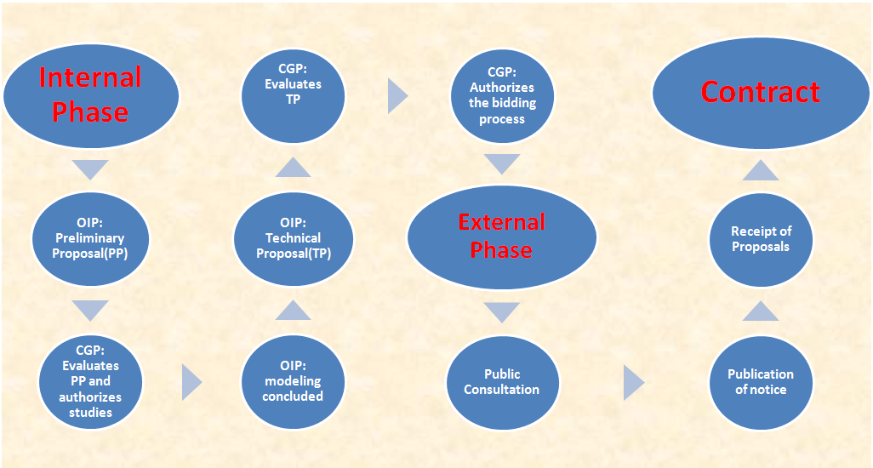
FIGURE 2 The Process of Planning and Contracting
(Source: Authors)

GUARANTEES

Irrespective of how good the project preparation and how appropriate the PPP model adopted, guarantees may still be needed by the investors should any default of public sector financial obligation occur. The guarantees available in Brazil provide increased comfort to the private partner, as they are designed to be promptly implemented, without the intervention of the Judiciary.

The PPP law (Article 8) allows the Contracting Entity to offer several forms of guarantee, which should be clearly specified in the bidding documents, including:

Guarantees given by the PPP Guarantee Fund (FGP)

Guarantees linked to revenues

Surety bonds contracted with insurance companies

Guarantees provided by international financial institutions, such as the World Bank (Matsukawa and Habeck 2007)

A state company established to provide such guarantees

The PPP Guarantee Fund (FGP) was established by the government to guarantee the payment of financial public obligations under PPP projects awarded by federal agencies. It has its own assets, consisting of fixed and variable income securities and variable. The FGP capital is entirely public, subscribed by eligible shareholders (i.e., the Union and public companies and foundations). The legal limit for the FGP capital is R$6 billion (about US$3.8 billion), which is also the overall limit for the provision of guarantees by the Union. The CGP is managed by the Bank of Brazil.

In order to reduce the cost of raising finance, the FGP can also provide counter-guarantees to insurance companies, financial institutions and international organizations, which ultimately will assure payment of the public sector obligations to the private partner.

According to the PPP law, the public entity may only assume financial obligations with the private partner for payments related to services delivered. Consequently, until the beginning of project operations, all funding for the project (e.g., for construction) has to be provided by the private partner. It is interesting to note that the legal framework of several other countries does not have such restriction.

PROJECT FINANCE

Most PPP projects are financed and structured in the form of project finance, where the injection of funds by investors is guaranteed by the cash flow to be generated by the project.

Figure 3 depicts in a simplified way the relationship between the actors involved in project finance. The figure also highlights the important role played by the SPE, which is established by the successful bidder to implement and manage the project. SPE may have a variety of funding, such as the investors themselves (i.e., equity), private banks, pension funds, multilateral agencies, and the Brazilian Economic and Social Development Bank (BNDES).

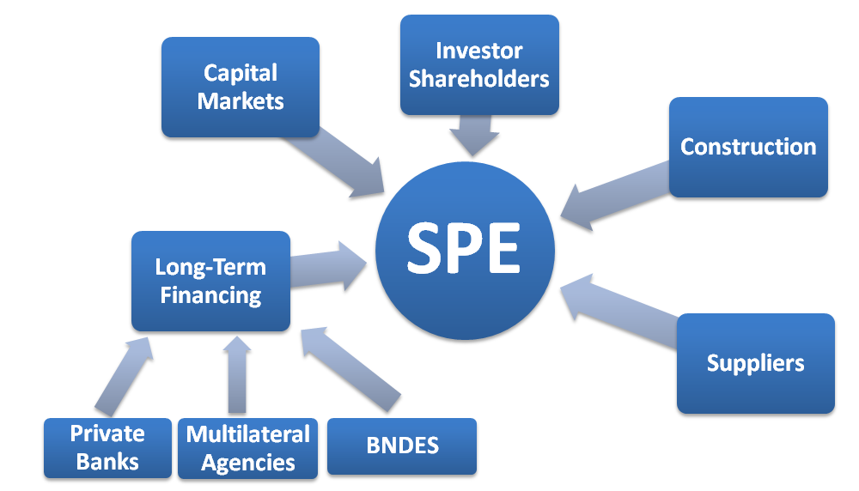

FIGURE 3 PPP Project Financing in Brazil
(Adapted from Paiva and Rocha 2005, p.11)
RECOMMENDATIONS FOR IMPROVING THE PPP LAW

While the Brazilian PPP law can be generally considered highly satisfactory, it seems that it could be improved regarding two particular aspects, namely public disclosure and mechanisms for renegotiation.
Public disclosure of concession agreements is highly desirable. This has several benefits: (a) it provides a further check on corruption, which in addition to its direct benefits can enhance the legitimacy of private sector involvement in often sensitive sectors; and (b) when the concession agreement relates to the provision of services to the public, it provides consumers with a clearer sense of their rights and obligations, and can facilitate public monitoring of concessionaire performance. The lack of transparency in concession agreements may lead to serious public concerns, as highlighted in a report by Transparency International (2005).

Concession laws should establish clear mechanisms for renegotiation and amendments (as a way to minimize contract distress and cancellation). The renegotiation of projects is not an unusual occurrence. In fact, about half of all concessions become subject to re-negotiation, often due to unrealistic cost and revenue assumptions. While not all renegotiation is undesirable, opportunistic renegotiation should be discouraged (Queiroz 2007).

The PPP law does not appear to be clear enough regarding the two above dimensions. In this regard, it could be improved through an amendment or specific regulation.

CONCLUSIONS

This paper reviewed how a PPP project can be prepared and implemented in Brazil, pointing out the main responsibilities of the public and private actors in the process. This is expected to serve as a general guidance for domestic and international investors interested in participating in competitive selection of concessionaires in Brazil.

A description was given of what is called PPP in Brazil, including the main phases and studies required for government approval and the bidding process to be carried out.

In order to make PPP projects more attractive to private investors, the Brazilian PPP law provides the Contracting Entity with several options to extend guarantees to the private partner, including those given by the PPP Guarantee Fund, guarantees linked to revenues, and guarantees provided by international financial institutions.

A main advantage of stimulating private investments through PPP agreements is the possibility to explore all the flexibility and managerial competence of the private sector in order to accelerate the implementation in Brazil, even with the limited budget available, of priority projects in critical areas such as infrastructure, education, and health.

In summary, the Brazilian PPP framework provides for a balanced partnership that is advantageous to both contracting parties. While the government has an opportunity to accelerate the completion of new investments required to promote the country’s economic and social development, the private partners, domestic or international, have an opportunity to generate long lasting cash flows with relatively low risks in view of the financial support and guarantees from the public partner.

While the Brazilian PPP law can be generally considered highly satisfactory, it seems that it could be improved regarding two particular aspects, namely public disclosure and mechanisms for renegotiation.

REFERENCES

Matsukawa, Tomoko, and Odo Habeck. 2007. “Review of Risk Mitigation Instruments for Infrastructure Financing and Recent Trends and Developments.” Trends and Policy Options No. 4, Private Participation in Infrastructure Advisory Services (PPIAF), Washington, DC, USA.

http://www.ppiaf.org/ppiaf/publications/Trends%20and%20Policy%20Options

(Accessed on July 27, 2011)

Perrupato, Marcelo. 2009. “Logistic Infrastructure Scenario in Brazil.” Toll Road Summit of the Americas: A Bridge to the Future, International Bridge, Tunnel and Turnpike Association (IBTTA), Sao Paulo, Brazil, November 16-17, 2009.

http://www.ibtta.org/Events/pastpresdetail.cfm?ItemNumber=4365&navItemNumber=883

(Accessed on July 27, 2011)

Queiroz, Cesar. 2007. “Public-Private Partnerships in Highways in Transition Economies: Recent Experience and Future Prospects.” Transportation Research Record: Journal of the Transportation Research Board, Issue Number 1996, pp 34-40. National Research Council, Washington, D.C., USA.

http://pubsindex.trb.org/view.aspx?id=801043 (Accessed on July 27, 2011)

Queiroz, Cesar, and Henry Kerali. 2010. “A Review of Institutional Arrangements for Road Asset Management: Lessons for the Developing World.” World Bank Transport Paper No. TP-32. Washington, D.C., USA.

http://go.worldbank.org/6HDCYBMRT0

(Accessed on July 27, 2011)

Ribeiro, Mauricio, and Lucas Prado. 2007. “Comentários à lei de PPP: fundamentos econômico-jurídicos.” São Paulo, Brazil: Malheiros Editores. 477p.

Paiva, Silvia M. Caldeira, and Carlos A. A. Rocha. 2005. “Parceria Público-Privada: O papel do Senado Federal na discussão e aprovação da lei 11.079, de 2004.” Brasília: Consultoria Legislativa do Senado Federal.
http://www2.senado.gov.br/bdsf/item/id/113 (Accessed on March 3, 2010)

Rocha, Gustavo, and Joao Horta. 2010. Parcerias Público-Privadas: Guia Legal para Empresários, Executivos e Agentes do Governo.” Belo Horizonte, Brazil: Prax Editora, 2010. 104 p.

Transparency International. 2005. “Granting a Concession for the Trakia Motorway: Interim Report.” Sofia, Bulgaria.

http://www.transparency-bg.org/?magic=0.5.71.2 (Accessed on October 3, 2007)

